**Linux Architecture**

Linux is an open-source UNIX-based operating system. The main component of the Linux operating system is Linux kernel. It is developed to provide low-cost or free operating system service to personal system users, which includes an X-window system, Emacs editor, IP/TCP GUI, etc.

**Components of Linux:**

Like any operating system, Linux consists of software, computer programs, documentation, and hardware.

**The main components of Linux operating system are:**

* Application
* Shell
* Kernel
* Hardware
* Utilities

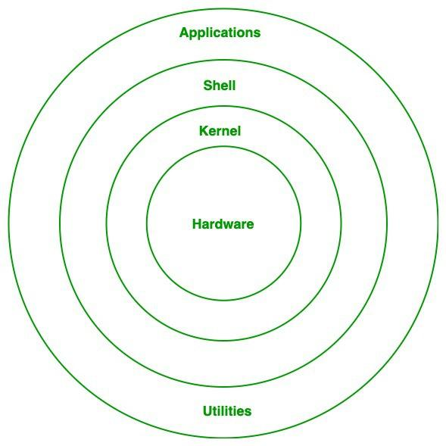

1. Linux Architecture

**Hardware Layer:**

Hardware layer of Linux is the lowest level of operating system track. It is plays a vital role in managing all the hardware components. It includes device drivers, kernel functions, memory management, CPU control, and I/O operations. This layer generalizes hard complexity, by providing an interface for software by assuring proper functionality of all the components.

**Kernel:**

[Kernel](https://www.geeksforgeeks.org/introduction-to-linux-operating-system/) is the main core component if Linux, it controls the activity of other hardware components. It visualizes the common hardware resources and provide each process with necessary virtual resources. It makes the process to wait in the ready queue and execute in consequently to avoid any kind of conflict.

**Different of types of kernels:**

**1.1. Monolithic Kernel:**

[Monolithic kernel](https://www.geeksforgeeks.org/kernel-in-operating-system/) is a type of operating system kernel, where all the concurrent processes are executed simultaneously in the kernel itself. All the processes share same memory recourses.

**1.2. Micro kernel:**

In [micro kernel](https://www.geeksforgeeks.org/kernel-in-operating-system/) user services and kernel services are executed in separate address spaces. User services are kept in user address space and kernel services are kept in kernel address space.

**1.3. Exokernel:**

[Exo-kernel](https://www.geeksforgeeks.org/kernel-in-operating-system/) is designed to manage hardware resources at application level. High level abstraction is used in this operating system to offer hardware resources access to kernel.

**1.4. Hybrid kernel:**

It is the combination of both monolithic kernel and microkernel. It has speed and design of monolithic kernel and modularity and stability of microkernel.

**Hypervisors**

A software package or kernel module extension that runs on a host OS and emulates hardware platforms for running guest OSes. VMware Workstation, Virtual Box, and QEMU are examples of hypervisors.

**Main Subsystems of kernel:**

* **Process scheduler:** Responsible for fairly distributing the the processing time among all the concurrently running process.
* **Memory management unit:** This kernel sub unit is responsible for proper distribution of memory resources among the concurrently running process.
* **Virtual file system:** This subsystem provides interface to access stored data across different file system and different physical media.

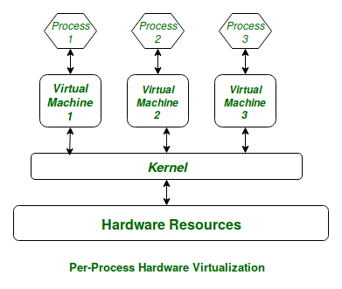

1. Linux Kernel

**Shell:**

[Shell](https://www.geeksforgeeks.org/introduction-linux-shell-shell-scripting/)can be determined as the interface to the kernel, which hides the internal execution of functions of kernel from the user. Users can just enter the commend and using the kernel’s function that specific task is performed accordingly.

**Different types of shell:**

**1. Command Line shell:**

Executes the command provided by user given in the form command. A special program called terminal in executed and the result is displayed in the terminal itself.

**2. Graphical User Interface:**

Executes the process provided by user in graphical way and output is displayed in the graphical window.

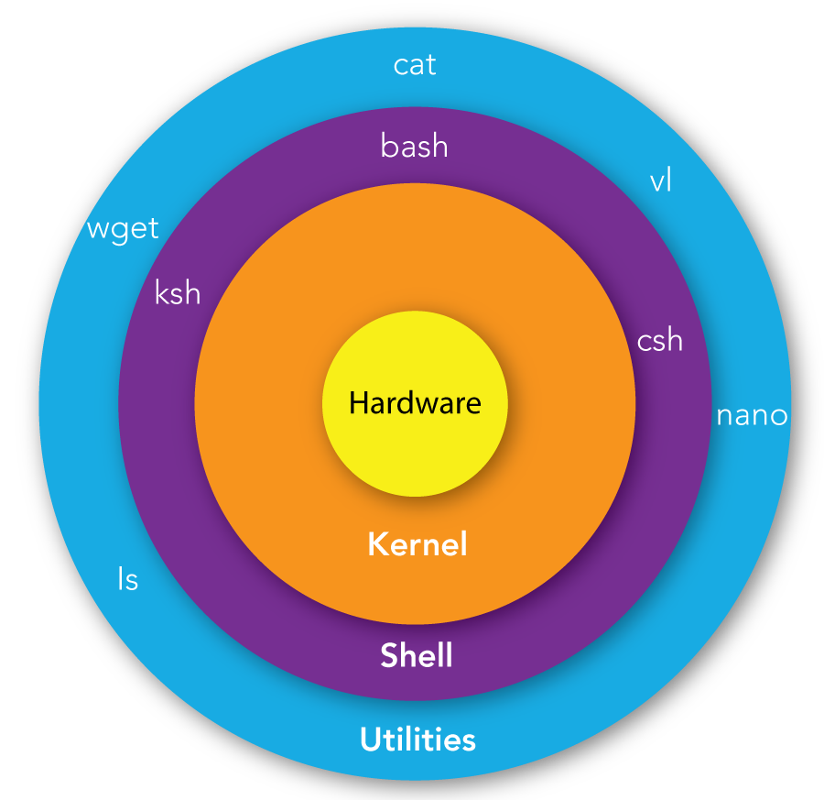

1. Linux shell

**System utility:**

System utilities are the commend line tools that preforms various tasks provided by user to make system management and administration better. These utilities enable user to perform different tasks, such as file management, system monitoring, network configuration, user management etc.

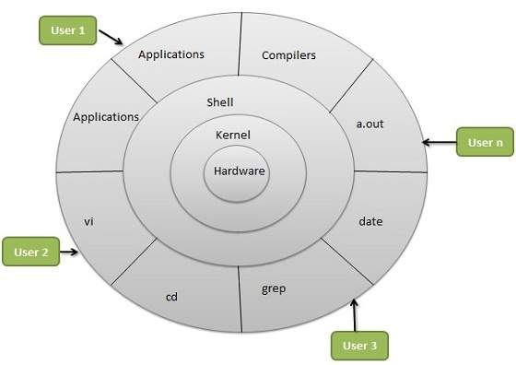

1. Linux OS Architecture